EXCLUSIVE DALHOUSIE/DHARMSALA

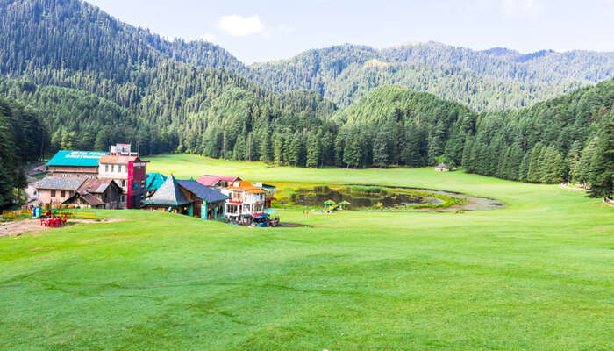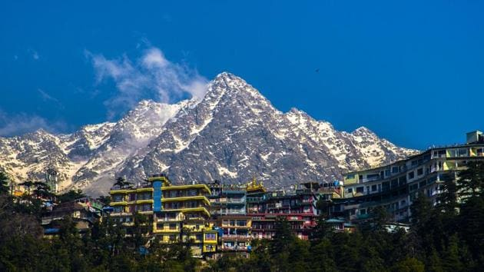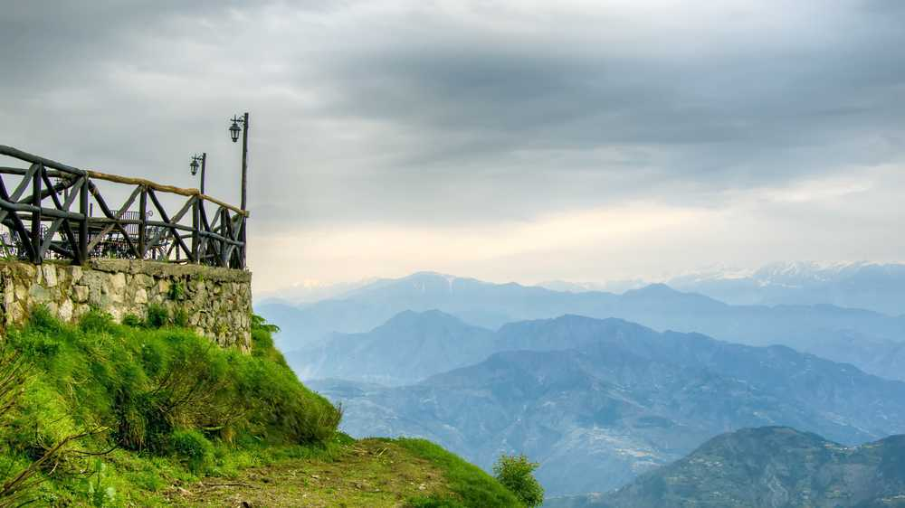

Tour Package 4 Nights 5 Days Package
Places covered –Mcleod Ganj- Bhagsunag –Ranikhet - Kajjar
Fixed dates: October 2021
No. Of adults: 12 Child
Meals: Breakfast and dinner
Land package is 9,900 per adult
Flight: 5000 per adult
(Sightseeing, accommodation and flight)
Total INR 14,900/- (Per 2 Pax)

TOUR PACKAGE INCLUDES

- Welcome drink on Arrival(Non –alcoholic)
- Accommodation on double or triple sharing basis at 3* hotels.
- Meals (Daily Breakfast and Dinner at all places )4B/F & 4D
- Sightseeing as per above Itinerary by Separate Vehicle.
- Flights ticket from Chennai to Delhi to and fro
- Airport transfers to and fro
- All inclusive (Fuel, Driver Allowance, Parking Toll Tax, State Tax.)

TOUR ITINERARY

DAY-1 Delhi – Dharamshala (520 kms / 11-13 hrs)
Reach in Delhi by Air or Train. After reaching Delhi drive to Dharamshala by Cab reach in Dharamshala in the evening. On arrival at Dharamshala check in to the hotel. Dinner and overnight stay at hotel.

DAY-2 Dharamshal Local Sightseeing
After Breakfast, today drive to local sightseeing including official residence of Dalai lama in Mcleodganj, St John church, Monasteries & Bhagsunath temple, the oldest temple in Dharamshala. Dinner and overnight stay at hotel.

DAY-3: Dharamshal – Dalhousie. (130 kms / 3-4 hrs)
After breakfast check out from the hotel and drive to Dalhousie (130 Kilometers). Dalhousie is popular hill station situated at 2040 mts in the outer slop of the Dhauladhar range of Himachal Pradesh. On arrival, Check in to the hotel. Dinner and overnight stay at hotel.

DAY-4: Dalhousie – Khajjiar – Dalhousie (25 kms)
Morning drive to Khajjiar, one of the most scenic Plateau known as the mini Switzerland of India and is surrounded by dense pine and deodar forests. There is a small lake in the center with a floating island and 9-hole golf course here. Enjoy zorbing & paragliding. Return to hotel. Dinner and overnight stay in Dalhousie.

DAY-5: Dalhousie Delhi (550 kms / 12-14 hrs)
Today after breakfast check out from the hotel and drive to Delhi (550 Kilometers) by cab. Reach in Delhi in the evening time and drop at Railway station or Airport as desire.

BOOKING CONFIRMATION
- Full flight charges if any
- 75% Amount has to be paid well in advance to make the booking
- 25 % of the amount to be paid 10 days before the journey commences.
- 25% of amount only will be returned if cancelled on or before a week of travel.

Excluded in the package: DOES NOT INCLUDE
- Expenses of personal nature such as tipping, porters, laundry, telephones, Cameras fees.etc
- Entrance fees at any point.
- Any claim or delay charges due to natural calamities, land slide, road blockage etc. Or any other things which are not mentioned in cost included column.
- Any Train, Airlines fare, ticket of rope way, ponies, union transport charges, etc.
- Any meals other than those mentioned above package.
- Arrival day Breakfast & departure day dinner not included
- Cost due to upgrading /changing hotels, Room type, luxury cars etc.
- Entrance fees to Amusement parks, Boating & other theatre show charges.
- Any portage at airports and hotels, tips, insurance, wine, mineral water, telephone charges, and all items of personal nature.
- Expenses caused by factors beyond our control like rail and flight delays, roadblocks, and vehicle mal-functions, political disturbances etc.
- 2 years and above Kids will be charged as per the flight tickets (full fare)....
- Other than that everything will be complimentary if the kid is below the age of 5. Above 5 to 9 year 50% of the adult charge will be charged. 9 and above will be considered as adults.
Cancellation Policy:
In the event of cancellation of tour / travel services due to any avoidable / unavoidable reason/s we must be notified of the same in writing. Cancellation charges will be effective from the date we receive advice in writing, and cancellation charges would be as follows:
- 45 days prior to arrival: 10% of the Tour / service cost
- 15 days prior to arrival: 25% of the Tour / service cost
- 07 days prior to arrival: 50% of the Tour / service cost
- 48 hours prior to arrival OR No Show: No Refund
***Cancellation due to covid lockdown or any other covid issues may be sorted by guest themselves. We will give our full support to make you comfortable but last minute cancellation or lockdown cannot make your money refund as the arrangements were made for you. Hope you understand that we are also facing the same difficulty. This is consent for you to take the risk to follow the protocol and travel safe, knowing the situation. Please carry your vaccination certificate or RTPCR report as per the regulations, as per the destination protocol.

